 Sec 6.3 - Describing Data

Data Graphs Name:

1. 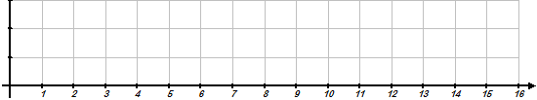Create a Basic Box and Whisker Plot of the following data sets:
2. **3, 4, 4, 8, 9, 12, 15**



1. **2, 9, 3, 14, 3, 2, 3**



1. **5, 9, 14, 12, 10, 3, 15, 5, 8, 7**

1. Determine the suggested statistical measures and answer the questions based on the graph.
2. Minimum =
3. Q3 =
4. 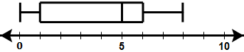IQR =
5. Range=

1. Which quartile has the most variation?
2. Determine the suggested statistical measures and answer the questions based on the graph.
3. Minimum =
4. Q1 =
5. 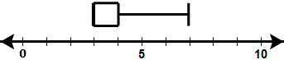IQR =
6. Median=
7. Which quartile has the most variation?

1. Determine the suggested statistical measures and answer the questions based on the graph.
2. Minimum =
3. Maximum =
4. 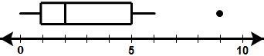Outliers =
5. Median=
6. Given the data set , 5, 80, 75, 62, 64, 90, 75, 94, 100, determine which if any of the data points are outliers by definition **($Outler<Q_{1}-1.5∙IQR$** **or $Q_{3}+1.5∙IQR<Outlier$** **)** and create an Advanced Box and Whisker plot.

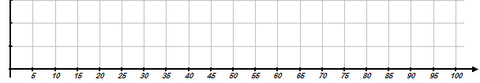

*M. Winking Unit 6-3 page 145*

1. Given a data set has a Median of 10 and an Inner Quartile Range of 5, what is the range of values that Q3 could possibly be?
2. Given the data set :

**20, 15, 16, 15.5, 8, 11, 15.2, 3, 11**

Create a dot plot of the data.

1. Match the following data sets represented in the dot plots below with the most appropriate measure of center based solely on the data.

__________A. MEAN _________ B. MEDIAN _________ C. MODE

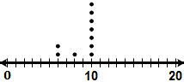

**III.**

**II.**

**I.**



1. Which dot plot below shows the most variation and which shows the least variation?

__________A. LEAST VARIATION _________ B. MOST VARIATION

**III.**

**II.**

**I.**





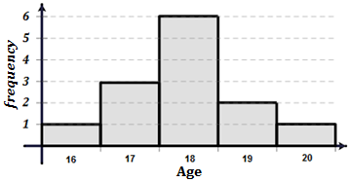

1. A coach was hosting a baseball camp for high school and college students over the summer.
2. He needed an additional release form signed but only students who were 18 years and older could sign it for themselves. Based on the histogram at the right, how many players at the camp are under 18 and will still need their parent’s signature?
3. What is the Lower Quartile (Q1) for the data set?
4. 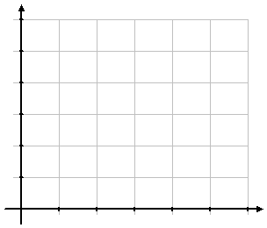What is the Upper Quartile (Q3) for the data set?
5. What is the Interquartile Range for the data set?

***frequency***

1. An attendant at the counter of a bowling alley kept a log of what size bowling shoes were rented over a half of hour of work and recorded the following shoe sizes that were rented

{8, 9, 8.5, 12, 11.5, 12, 10, 10.5, 10, 9, 11, 10, 9, 9.5}

**9 – 9.5**

**8 – 8.5**

**10 – 10.5**

**11 – 11.5**

**12 – 12.5**

**13 – 13.5**

*M. Winking Unit 6-3 page 146*

***Shoe Size***

1. Consider the following data set

|  |  |  |  |  |  |  |
| --- | --- | --- | --- | --- | --- | --- |
| ***Year*** | ***Car*** | ***0-60 Time*** |  | ***Year*** | ***Car*** | ***0-60 Time*** |
| 2009 | Mustang V-6 | 6.5 |  | 2010 | Camaro V6 | 5.9 |
| 2009 | Nissan Sentra SE-R | 6.4 |  | 2010 | Camaro SS V8 | 4.6 |
| 2009 | Volvo C30 | 6.3 |  | 2010 | Mustang GT V8 | 4.8 |
| 2009 | Mini Cooper S | 6.2 |  | 2010 | Porsche 911 Turbo | 3.2 |
| 2009 | Mazda 6 s | 6.1 |  | 2010 | Hyundai Genesis | 6.9 |
| 2009 | Mitsubishi Eclipse GT | 6.1 |  | 2010 | Mitsubishi Lancer | 5.0 |
| 2009 | Volkswagen GTI | 6.0 |  | 2010 | Subaru WRX STI | 4.8 |
| MC900437100[1]2009 | Toyota Camry | 5.8 |  | 2010 | Audi A4 | 6.9 |
| 2009 | Chevrolet Cobalt SS | 5.5 |  | 2010 | Cadillac CTS | 6.8 |
| 2009 | Mazda speed 3 | 5.4 |  | 2010 | Nissan 370Z | MC900157569[1]4.9 |

1. What is the Range of the 0-60 times? b. What should the width of the class interval

(assuming 5 classes)?

1. 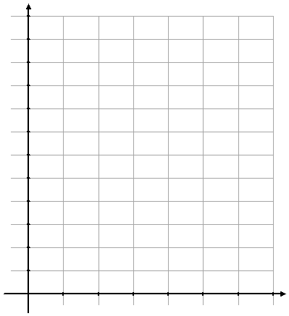Create a frequency histogram using interval notation and 5 classes.
2. Create a frequency histogram using standard notation classes.

***frequency***

***frequency***

1. Consider the following data set **{12.2, 13.4, 20.2, 31, 10.8, 9.2, 28.7, 22, 30.7, 8.3, 9.8, 10.8}**

What is the RANGE of the data?

What would be an appropriate class width assuming 5 classes are to be created?

Using interval notation, provide 5 appropriate classes for a frequency table or histogram.

*M. Winking Unit 6-3 page 147*

1. Match each data set with the appropriate histogram shown at the right.

**_____A. {2, 2, 3, 4, 12, 14, 14, 16, 19}** **_____**B. **{1, 2, 3, 3, 4, 5, 8, 14, 17} _____**C. **{1, 2, 4, 4, 6, 10, 12, 15, 18}**

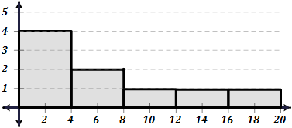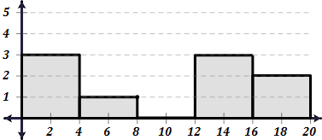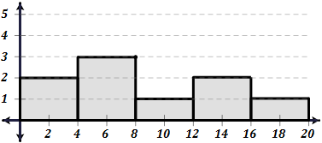

**III.**

**I.**

**II.**

*frequency*

*frequency*

*frequency*

1. 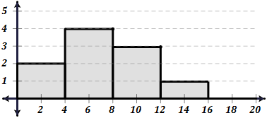What is the approximate mean and standard deviation of the data shown in the histograms?

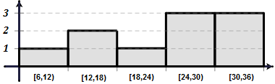**A.** B.

*frequency*

*frequency*

1. Match each distribution name with each histogram shown below.

**_____A. Symmetric Normal** **_____**B. **Skewed Right _____**C. **Skewed Left _____**D. **Bi-modal _____**E. **Uniform**

**III.**

**I.**

**II.**

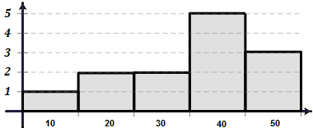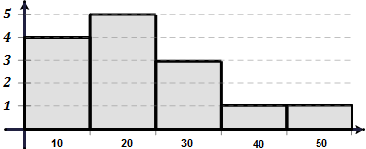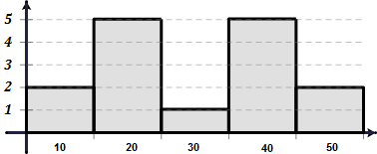

**V.**

**IV.**

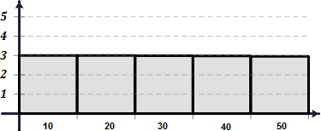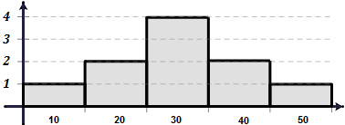

*M. Winking Unit 6-3 page 148*